**Response for Assignment 5.1**

Below screenshot shows the output of the program which shows the use of try/except block

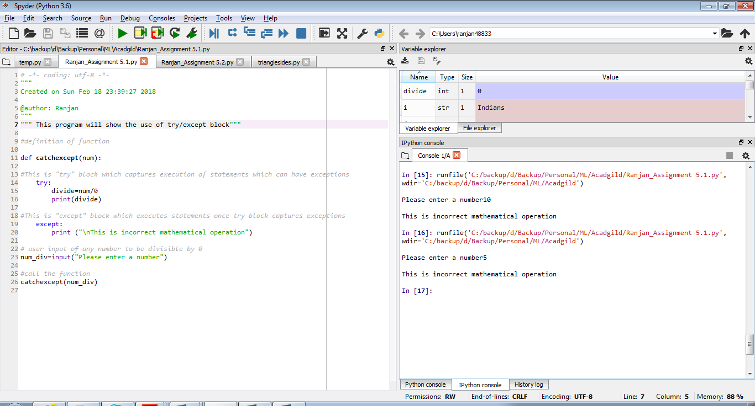

**Source Code**

#definition of function

def catchexcept(num):

#This is "try" block which captures execution of statements which can have exceptions

try:

divide=num/0

print(divide)

#This is "except" block which executes statements once try block captures exceptions

except:

print ("\nThis is incorrect mathematical operation")

# user input of any number to be divisible by 0

num_div=input("Please enter a number")

#call the function

catchexcept(num_div)